The Project Entitled

LIVE VIDEO STREAMING

Submitted in partial fulfilment of academic requirements for the award of the degree of
Bachelor of Engineering (Computer Science and Engineering)

By

DEEKSHA GAINI
(2451-10-733-063)
R.SAHITHYA
(2451-10-733-068)
S.TEJASWI
(2451-10-733-069)



Department of Computer Science and Engineering
M.V.S.R. ENGINEERING COLLEGE
(Affiliated to Osmania University & Recognized by AICTE)
Nadergul, Saroor Nagar Mandal, Hyderabad – 501 510
2012-13.

Department of Computer Science and Engineering
M.V.S.R. ENGINEERING COLLEGE
(Sponsored by Matrusri Education Society, Estd. 1980)
(Affiliated to Osmania University & Recognized by AICTE)
Nadergul, Saroor Nagar Mandal, Hyderabad – 501 510



CERTIFICATE

This is to certify that the project entitled “LIVE VIDEO STREAMING”, is being submitted by Ms. DEEKSHA GAINI, R.SAHITHYA, S.TEJASWI bearing H.T No 2451-10-733-063,2451-10-733-068,2451-10-733-069 respectively in partial fulfilment of academic requirements for the award of the degree of BACHELOR OF ENGINEERING in COMPUTER SCIENCE AND ENGINEERING from MVSR Engineering College, affiliated to OSMANIA UNIVERSITY, is a record of bonafide work carried out by him under the guidance and supervision of the faculty (CSED). The results embodied in this project report have not been submitted to any other University or Institute for the award of any degree or diploma to the best of my knowledge and belief.

Project Incharges:

Dr. J .Gopal Rao
Professor
V.Sridhar
Assistant Professor
Dept. of CSE.
MVSR Engineering College

ACKNOWLEDGMENT

I take this opportunity to express my profound and sincere gratitude to all those who helped us in carrying out this project successfully.

At the very outset, I am thankful to our principal Sri Dr.P.A.Sastry and Sri J.Prasanna Kumar, Professor and Head, Department of Computer Science and Engineering, MVSR Engineering College, Hyderabad for their consent to do the project work as a part of our B.E Degree (CSE). We thank them for their valuable suggestions and advice throughout our stay at the college, during our project work.

I would like to thank our Internal Project in-charges Dr J Gopal Rao, Professor and V.Sridhar, Assistant Professor, Department of Computer Science and Engineering, MVSR Engineering College for his/her useful suggestions, guidance and encouragement.

We thank the teaching and non-teaching staff of CSE for extending their support.

Finally we are thankful to our parents for their cooperation and support throughout all endeavours in our life.

DEEKSHA GAINI (2451-10-733-063)
R.SAHITHYA (2451-10-733-068)
S.TEJASWI (2451-10-733-069)

Table of Contents

S.No. | Chapter | Pg.no.
1 | Abstract | 5
2 | Introduction | 7
3 | Flow Chart | 9
4 | UML Diagrams | 10
5 | Code | 12
6 | Output | 14
7 | Reference | 16
8 | Appendix | 17

1.0 ABSTRACT

TITLE: LIVE VIDEO STREAMING

INTRODUCTION
- Streaming media is multimedia that is constantly received by and presented to an end-user while being delivered by a provider. Its verb form, "to stream", refers to the process of delivering media in this manner; the term refers to the delivery method of the medium rather than the medium itself.

- A client media player can begin playing the data (such as a movie) before the entire file has been transmitted. Distinguishing delivery method from the media distributed applies specifically to telecommunications networks, as most other delivery systems are either inherently streaming (e.g., radio, television) or inherently nonstreaming (e.g., books, video cassettes, audio CDs). For example, in the 1930s, muzak was among the earliest popularly available streaming media; nowadays Internet television is a common form of streamed media. The term "streaming media" can apply to media other than video and audio such as live closed captioning, stock ticker, and real-time text, which are all considered "streaming text". The term "streaming" was first used in the early 1990s as a better description for video on demand on IP networks; at the time such video was usually referred to as "store and forward video", which was misleading nomenclature.

- Live streaming, delivering live over the Internet, involves a camera for the media, an encoder to digitize the content, a media publisher, and a content delivery network to distribute and deliver the content.

PROBLEM STATEMENT
- Streaming media is multimedia that is constantly received by and presented to an end-user while being delivered by a streaming provider.
- video is a kind of multimedia and if one wants to watch some video contents stored on some server over the Internet from some remote machine then, as the size of video content is relatively large, it will take time to get transferred completely and after that to play it.
- Rather than doing this, one can 'stream' that video from where its stored and those who wish to view that video can access it from their machine, only the difference here is that, end user does not need to wait until complete video gets downloaded, but can start watching it as soon as it starts streaming. So, watching video and downloading video are being done simultaneously.
- This type of streaming is known as on-demand video streaming, because the video is stored on the machine and is streamed when it is demanded. And the machine which does this streaming is called as streaming server.
- The Basic version of above streaming is implemented in this mini project.

IMPLEMENTED USING
1. Linux OS – Ubuntu 12.04.1 LTS, Kernel 3.2.0-29
2. GCC Compiler 4.6.3
3. Gstreamer 0.10.13
4. HTML 5 Supported Browser

2.0 Introduction

This approach of on-demand video streaming is very good if the video is already present on the streaming server. But, this is not the case always. Sometimes, you need to access video contents which are not already present on the server, but rather are being generated dynamically. For example, live sport such as football, game is being played and at the same time you can watch it on your television or computers. So, such kind of streaming of videos is known as live video streaming.

Here, in this project a file already available on server and is transcoded using gstreamer utility gst-launch and at the same time its being live streamed.

For simplicity only one file is on server. And its being transcoded into WebM format and stream it.

On client's browser (which supports HTML5), load the video tag for making request to server. A simple html code for doing it is given below,
<html>
<body>
<h1> Test for simple WebM Live streaming </h1>
<video src="http://127.0.0.1:8800/live_stream.ogg" type="video/ogg" "autoplay="autoplay" controls="controls" height="360" width="640" >
</video>
</body>
</html>
Here, IP address and port specified in the URL should be changed accordingly, i.e. IP address of machine where your server runs and port on which you are going to listen.

In simple terms, the streaming server keeps listening to a dedicated port for any request for live stream. When it receives a request from some client, it responds for that request as a live stream. This happens as follows,

When client loads video tag, in this case above mentioned html code, browser sends a HTTP GET request, which has following format,
GET /live_stream.webm HTTP/1.1
Host: 127.0.0.1:8800
Connection: keep-alive
Referer: file:///home/toshish/Desktop/vid_tag.html
User-Agent: Mozilla/5.0 (X11; U; Linux i686; en-US) AppleWebKit/534.10 (KHTML, like Gecko) Chrome/8.0.552.224 Safari/534.10
Accept-Encoding: gzip,deflate,sdch
Accept-Language: en-US,en;q=0.8
Accept-Charset: ISO-8859-1,utf-8;q=0.7,*;q=0.3 Range: bytes=0-1024
This request means that, browser has requested something called as live_stream.webm to the Host 192.168.2.2 who is listening on port 8800. User-Agent shows information about client browser. Here, important field for us is 'Range', its value is "bytes=0-1024", this means that, browser has requested for first 1025 bytes i.e. from 0th to 1024th byte of live_stream.webm.

Server sends response to this request. It is required to get file header. The HTTP response header is as follows,
HTTP/1.0 200 OK
Date: Sun, 07 Apr 2013 02:49:58 IST
Connection: close
Cache-control: private Content-type: video/webm
Server: MyServer
Sending response as 200 OK, so the client browser understands that it has got completely OK response from server and server is sending requested bytes to client.

But, when client receives whatever data required by it, i.e. mainly the header of the file, client resets the connection with the server, and sends another GET request exactly same as previous one from some other pseudo-random port which is different from previous.

But, this time connection is not reset by client after reading header, this time browser keeps reading data on the stream. So, like previous one, we again send the same HTTP response header to client and keep on sending data to the client.

gst-launch-0.10 oggmux name="mux" ! filesink location=/home/ashwin/Desktop/Live/live_stream.ogg uridecodebin uri=file:///home/ashwin/Videos/gravity.mp4 name="d" { d. ! ffmpegcolorspace ! theoraenc ! queue ! mux. } { d. ! progressreport ! audioconvert ! audiorate ! vorbisenc ! queue ! mux. }

The url of your source file, i.e. a file already available at you to the uri attribute of uridecodebin, and path of the new file to location attribute of filesink, both the attributes are shown above.
Above mentioned command is a gstreamer pipeline, this will transcode the given file to ogg file.

But, as transcoding is highly CPU extensive task and it requires lots of computation and processing, it takes a fair amount of time. Hence, here we can actually see the effect of live streaming when the file is being transcoded at the same time. Hence, choosing a file with fairly large size and resolution , so that transcoding will take fair amount of time and in between you can observe the live streaming of transcoded video (being dumped in live_stream.ogg in this case).

3.0 FLOW CHART
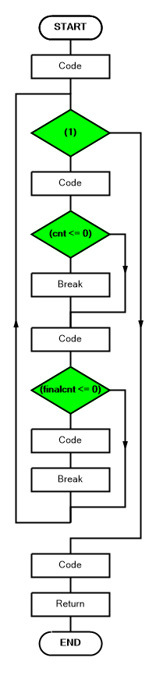

4.0 UML DIAGRAMS
USE CASE:
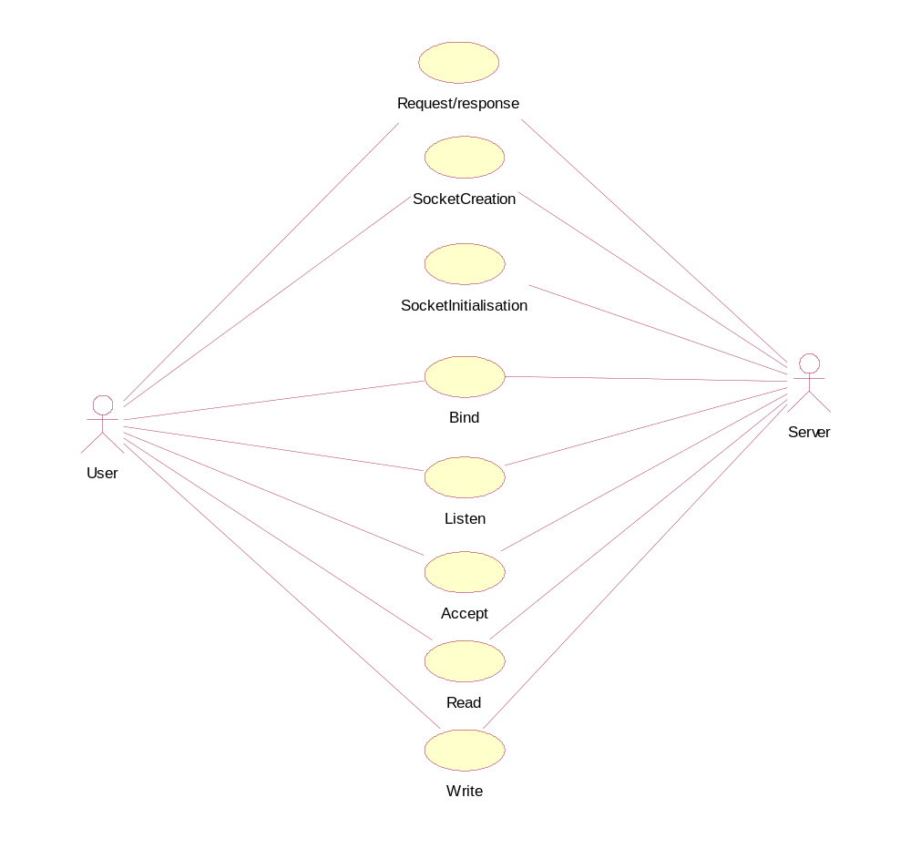
ACTIVITY DIAGRAM:
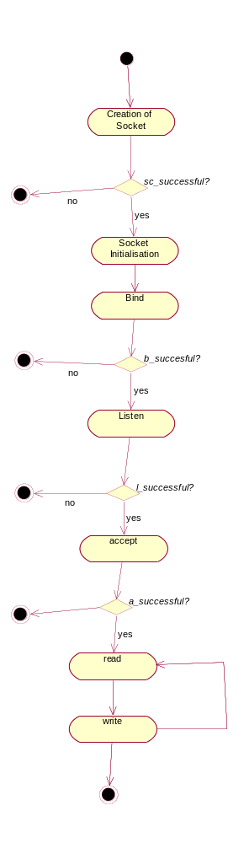

5.0 CODE
#include<stdio.h>
#include<stdlib.h>
#include<string.h>
#include<errno.h>
#include<arpa/inet.h>
#include<sys/socket.h>
#include<fcntl.h>
#include<signal.h>
#include<unistd.h>

int main() {

struct sockaddr_in sockserv, sockclient;
int socketfd, clientfd;
socklen_t clientsocklen;

int filefd;
int cnt;
int finalcnt = 0;
int chancecnt;

char buff[BUFSIZ], buff2[BUFSIZ];

signal(SIGPIPE, SIG_IGN);

printf("Signal handler for SIGPIPE over ridden : %s\n", strerror(errno));
socketfd = socket(AF_INET, SOCK_STREAM, 0);
printf("Socket Creation: %s\n", strerror(errno));

filefd = open("/home/ashwin/Desktop/gravity.ogg", O_RDONLY);
printf("File open: %s\n", strerror(errno));

sockserv.sin_family = AF_INET;
sockserv.sin_addr.s_addr = INADDR_ANY;
sockserv.sin_port = htons(9000);

bind(socketfd, (struct sockaddr *) &sockserv, sizeof (sockserv));
printf("Socket Bind: %s\n", strerror(errno));
listen(socketfd, 10);
printf("Socket Listen: %s\n", strerror(errno));
clientfd = accept(socketfd, (struct sockaddr*) &sockclient, &clientsocklen);

while (1) {
cnt = read(filefd, buff, 1025);
printf("Read %d bytes 1 from the file : %s\n", cnt, strerror(errno));
if (cnt <= 0)
break;

finalcnt = send(clientfd, buff, cnt, 0);
printf("Data written 1 = %d bytes: %s\n", finalcnt, strerror(errno));
if (finalcnt <= 0) {
memcpy(buff2, buff, cnt);
finalcnt = cnt;
close(clientfd);
printf("%s\n", strerror(errno));
break;
}

}
close(clientfd);
close(socketfd);
return 0;
}

Code For GST-LAUNCH (Gstreamer):

gst-launch-0.10 oggmux name="mux" ! filesink location=/home/ashwin/Desktop/live_stream.ogg uridecodebin uri=file:///home/ashwin/Desktop/gravity.mp4 name="d" { d. ! ffmpegcolorspace ! theoraenc ! queue ! mux. } { d. ! progressreport ! audioconvert ! audiorate ! vorbisenc ! queue ! mux. }

HTML Code:

<html>
<body>
<h1> Live streaming </h1>
<video src="http://127.0.0.1:9000/live_stream.ogg" type="video/ogg" "autoplay="autoplay" controls="controls" height="360" width="640" >
</video>
</body>
</html>

6.0 Output

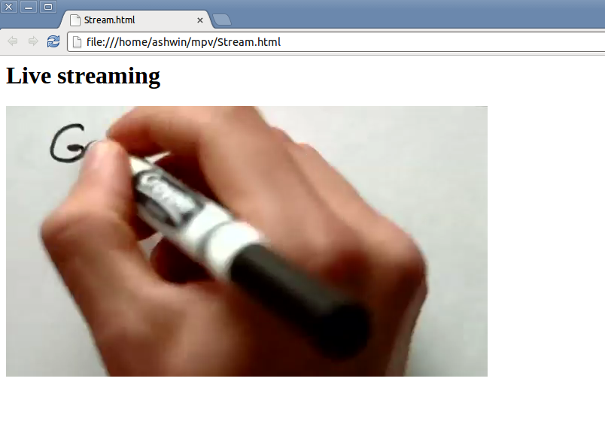
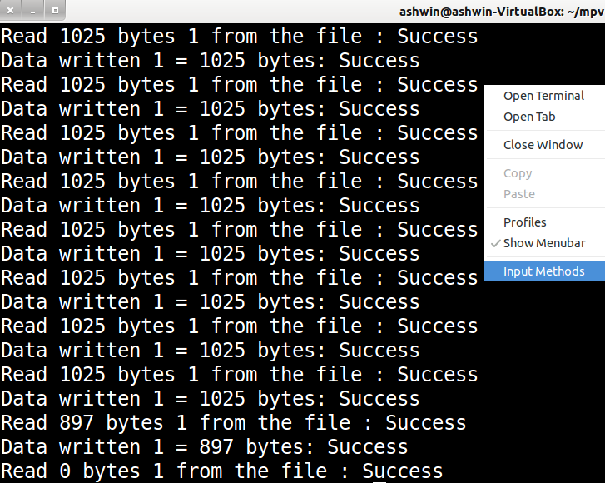

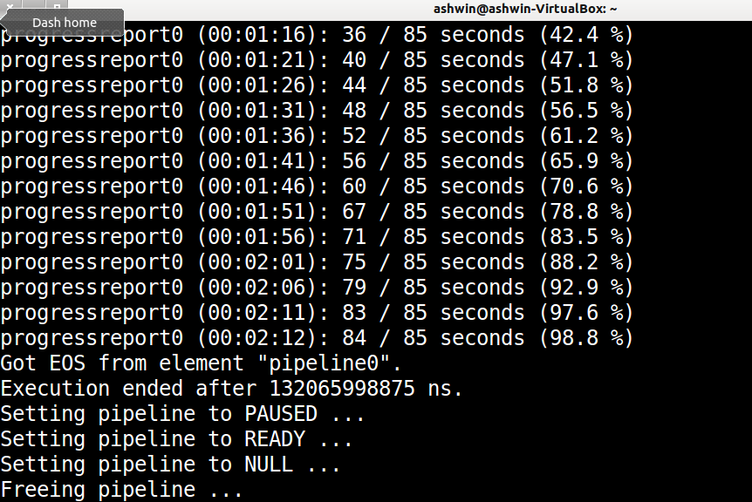

7.0 References

UNIX Network Programming: Networking APIs: Sockets and XTI; Volume 1

W. Richard Stevens

Computer Networks (5th Edition) Andrew S. Tanenbaum
- http://www.w3schools.com/tags/tag_video.asp
- http://en.wikipedia.org/wiki/Linux
- http://en.wikipedia.org/wiki/Ubuntu_(operating_system)
- http://en.wikipedia.org/wiki/GNU_Compiler_Collection
- http://en.wikipedia.org/wiki/GStreamer
- http://en.wikipedia.org/wiki/HTML5
- http://en.wikipedia.org/wiki/Google_Chrome

8.0 Appendix
About Linux And Ubuntu

- The Linux kernel is the operating system kernel used by the Linux family of Unix-like operating systems . It is one of the most prominent examples of free and open source software .
- The Linux kernel was initially conceived and created by Finnish computer science student Linus Torvalds in 1991
- Ubuntu a popular linux distribution is an ancient African word meaning 'humanity to others‘.
- Mark Shuttleworth along with a small team of developers from one of the most established Linux projects – Debian - and set out to create an easy-to-use Linux desktop, Ubuntu.
- The first Ubuntu release was Ubuntu 4.10 and was released on 20 October 2004.

About Gstreamer

- GStreamer is a pipeline-based multimedia framework written in the C programming language with the type system based on GObject.
- GStreamer allows a programmer to create a variety of media-handling components, including simple audio playback, audio and video playback,recording, streaming and editing. The pipeline design serves as a base to create many types of multimedia applications such as video editors, streaming media broadcasters and media players.

About GCC Compiler

- GCC is acronym for GNU C Compiler.
- GCC was first released March 22, 1987, available by ftp from MIT. Stallman was listed as the author.
- GCC is often chosen for developing software that is required to execute on a wide variety of hardware and/or operating systems.
- With GCC, most of the compiler is the same on every platform, so only code that explicitly uses platform-specific features must be rewritten for each system.

About HTML5

HTML5 is a markup language for structuring and presenting content for the World Wide Web and a core technology of the Internet. It is the fifth revision of the HTML standard (created in 1990 and standardized as HTML 4 as of 1997) and, as of December 2012, is a W3C Candidate Recommendation. Its core aims have been to improve the language with support for the latest multimedia while keeping it easily readable by humans and consistently understood by computers and devices (web browsers, parsers, etc.). HTML5 is intended to subsume not only HTML 4, but XHTML 1 and DOM Level 2 HTML as well.

About Google Chrome

Google Chrome is a freeware web browser developed by Google that uses the WebKit layout engine (later versions will use Blink, a fork of WebKit, except on iOS). It was released as a beta version for Microsoft Windows on September 2, 2008, and as a stable public release on December 11, 2008. As of February 2013, according to StatCounter, Google Chrome has a 37% worldwide usage share of web browsers making it the most widely used web browser in the world. Net Applications, however, indicates that Chrome is only third when it comes to the size of its user base, behind Internet Explorer and Firefox.

